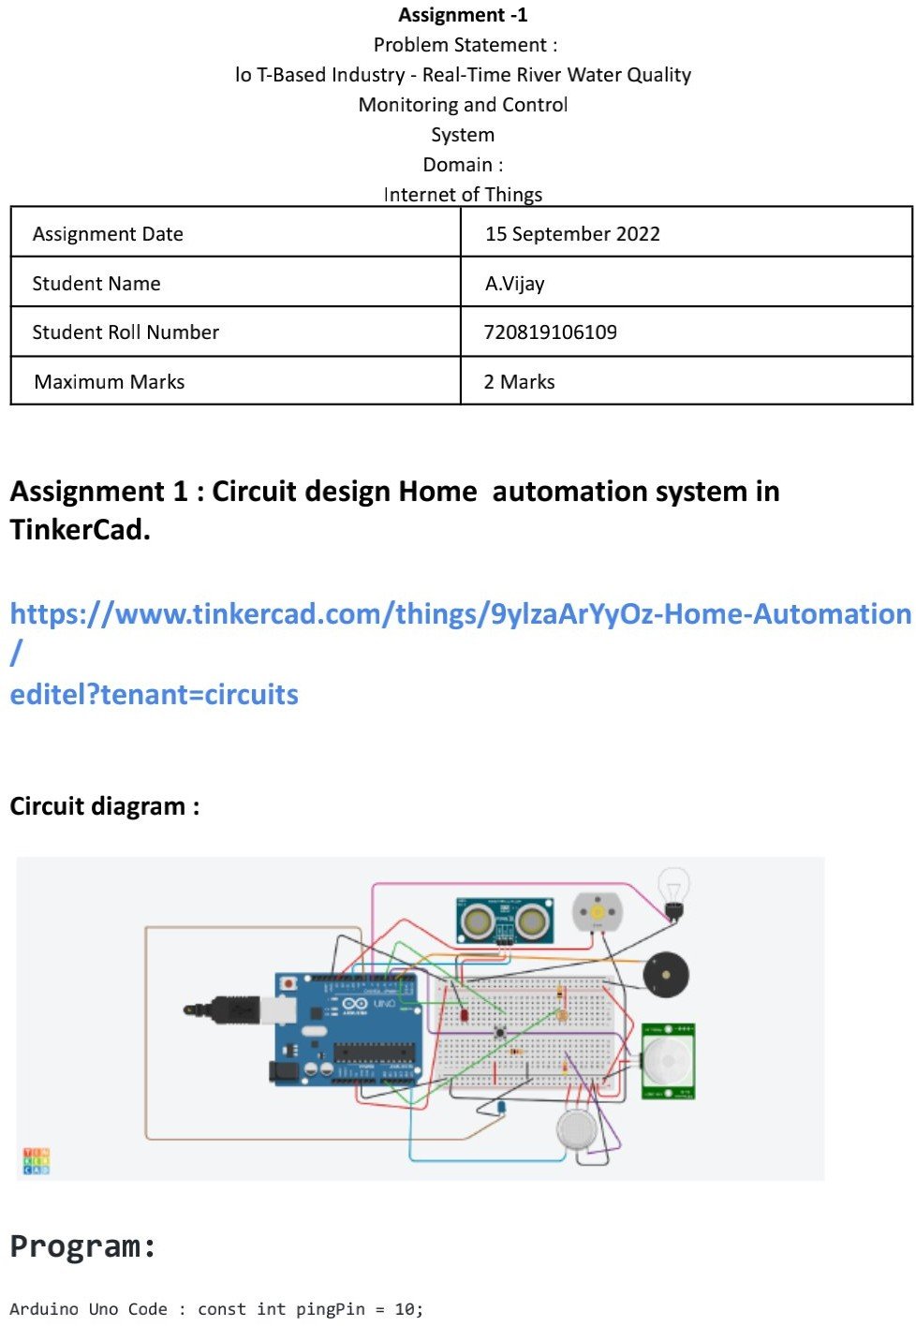

110719106039

Y Balaji

110719106018

110719106036

15 September 2022

2 Marks

V**.** MaheshBabu

